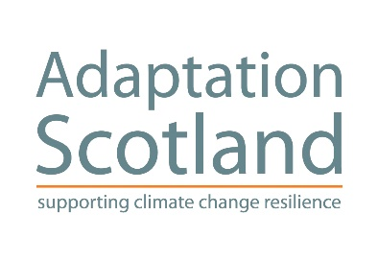
Adaptation Learning Exchange for Organisations:
Climate Ready Clyde Accelerator
November 2016 – May 2017

PART ONE: APPLICATION FORM
This form is intended to provide a commitment from participants to fully engage with the Accelerator programme. This includes attending two workshop / learning events (in November 2016 and May 2017) and undertaking a self-defined task during the programme. The form also includes some key questions that will help shape your participation.
Note: that for practical reasons we cannot accept more than 20 organisations into the programme. If demand exceeds this, then applications will be subject to a competitive selection process based on the information provided in the application form. Preference will be given to organisations that demonstrate a strong commitment to participating in the programme and using the accelerator to help progress their adaptation priorities.
Please send your application form to joseph@sniffer.org.uk by Thursday 10 November 2016.
Organisation:
Details for participant 1:
Name:
Job title:
Email:
Phone:
Briefly, how does adaptation relate to your work?

Details for participant 2:
Name:
Job title:
Email:
Phone:
Briefly, how does adaptation relate to your work?

Note: we recommend that participants have different job functions within the organisation. Feedback from previous programmes is that this was seen as very beneficial by the participants, as well as broadening the range of experience in the programme.

Q1. Why is your organisation interested in joining the Accelerator programme? What do you hope to gain by participating?

Q2. What are your organisation’s adaptation priorities over the next 12 months? Are there upcoming key milestones or commitments?

Q3. The Accelerator programme includes undertaking a ‘task’ during the project, what might this be for you?
We have an initial proposal to coordinate collaborative / peer-supporting task groups on: (i) understanding local climate impacts; (ii) creating a business case for adaptation; and (iii) project specific risk assessment. However, any task will need to be participant defined, aligning with your priorities. If needed, please contact us to discuss.

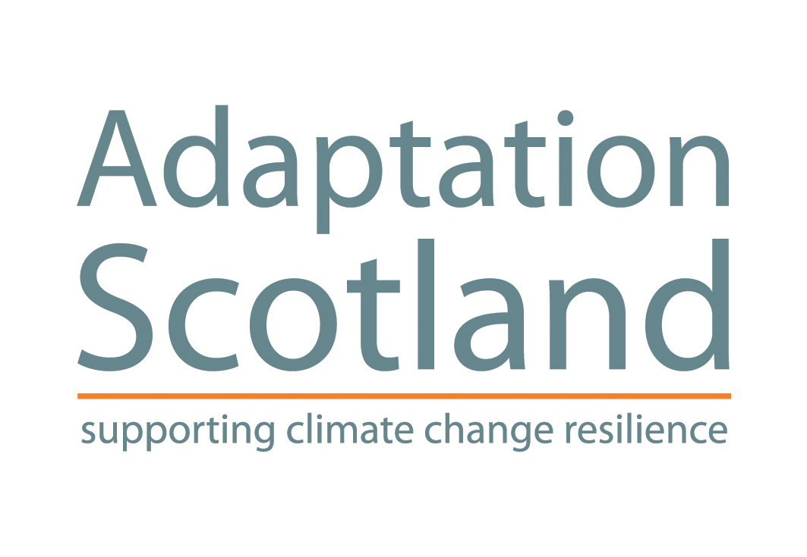
Adaptation Learning Exchange for Organisations:
Climate Ready Clyde Accelerator
November 2016 – May 2017

PART TWO: INFORMATION NOTE
This note provides some background information on Adaptation Scotland’s ‘Climate Ready Clyde Accelerator’ capacity building learning programme that will run from November 2016 to May 2017. For further information please contact Joseph Hagg (joseph@sniffer.org.uk / 0131 651 4654) or Kit England (kit@sniffer.org.uk).

What is the Adaptation Learning Exchange for Organisations?
Adaptation Scotland’s Adaptation Learning Exchange for Organisations is a collaborative process to support organisations build capacity and undertake adaptation planning. It aims to do this through the sharing of knowledge and ideas, highlighting good practice and increasing learning and networking opportunities. It continues to grow with more than 25 organisations already actively involved.
What is the Climate Ready Clyde Accelerator?
An Accelerator is a targeted professional learning programme that we offer as part of the Adaptation Learning Exchange for Organisations. It focuses on equipping participants with the skills and confidence to drive adaptation forward in their organisation. It also fosters peer support and learning between participants – and with the wider Adaptation Learning Exchange membership.
We have previously run similar programmes on a Scotland-wide basis (we will again in 2017). However, the Climate Ready Clyde Accelerator will focus on participants operating in the Glasgow City Region. This is based on feedback from previous participants (to enable practical collaboration) and expressed demand.
The Accelerator programme will hold two workshops (28-29 November 2016 and May 2017) that will provide expert training on adaptation, including climate impacts, values-based communication, and the adaptation process. These are an opportunity to share experience between participants building collaborative / peer support networks. We will also be inviting guest speakers who can share their work on adaptation, from Scotland (e.g. the wider ALE network) and elsewhere (e.g. London and Bologna). See Annex 1 for draft agenda for the 28-29 November workshop.
The second component of an Accelerator is a commitment from participating organisations to undertake a defined adaptation ‘task’ during the programme. These should be realistic and aligned with organisational priorities – the exact nature of the task will be up to the organisation. We have an initial proposal to coordinate collaborative / peer-supporting task groups on: (i) understanding local climate impacts; (ii) creating a business case for adaptation; and (iii) project specific risk assessment.
Is this the Climate Ready Clyde Initiative?
Climate Ready Clyde is a cross-sector partnership initiative supporting the development of a shared understanding of climate change risks and opportunities across the Glasgow City Region. This collaborative approach offers the potential for multiple benefits and efficiency savings. It is currently in a partnership establishment phase – for more information contact Kit England, Climate Ready Clyde Project Manager (kit@sniffer.org.uk)
The Climate Ready Clyde Accelerator is a time-limited learning programme that will run from November 2016 to May 2017, aiming to build the adaptive capacity of individuals and organisations in the region. This learning programme will be co-delivered by staff from Adaptation Scotland and Climate Ready Clyde.
Who can participate in the Climate Ready Clyde Accelerator?
This Accelerator learning programme is being targeted at organisations operating in the Glasgow City Region / Glasgow and Clyde Valley. It is open to public, private and third sector organisations interested in developing their organisational adaptive capacity and developing peer support and collaborative networks.
We aim to have between 10 and 20 organisations participating in the Accelerator, with two people from each organisation. We recommend that participants have different job functions within the organisation. Feedback from previous programmes is that this was seen as very beneficial by the participants, as well as broadening the range of experience in the programme.
If you aren’t based in the region, we are planning to run a Scotland-wide Open Accelerator in 2017. We also have a range of different programmes and activities under the Adaptation Scotland programme that you can engage with.
What is the commitment required of participants?
An Accelerator relies on people actively participating throughout the learning programme. The participants should have the intention of being able to attend both the November and May workshops. There should also be a commitment to undertake a self-defined adaptation task – and where appropriate participate in task groups that can support this work.
What comes after the Climate Ready Clyde Accelerator?
The Accelerator is a time-limited learning programme that will conclude in May 2017. Participants will have the opportunity to engage with other ongoing activities of the Adaptation Learning Exchange for Organisations and the wider Adaptation Scotland programme. The Climate Ready Clyde initiative is actively establishing a partnership approach for organisations in the region to support effective collaborative action.
So how can we join the Climate Ready Clyde Accelerator?
There is an Application Form. This gathers participant details and asks a few questions that will help us understand how the Accelerator can best meet your needs. Please note that for practical reasons we cannot accept more than 20 organisations into the programme. If demand exceeds this, then applications will be subject to a competitive selection process based on the information provided in the application form.
We encourage you to get in contact to find out more:
- Joseph Hagg, Adaptation Scotland (joseph@sniffer.org.uk / 0131 651 4654)
- Kit England, Climate Ready Clyde (kit@sniffer.org.uk / 0141 229 7738).

Please return the completed Application Form by Thursday 10 November.

ANNEX 1: DRAFT AGENDA for Workshop 1

Climate Ready Clyde Accelerator
28-29 November: 1st Workshop and Training Event
DAY ONE:
Session 1: Introduction to climate change and adaptation in Scotland
Basic introduction to adaptation, regional climate projections, and impacts (CCRA, 15 key consequences etc.)
Session 2: What are participants are doing already?
Aims to get participants to identify and share relevant existing or planned activities that contribute to adaptation.
Session 3: Communication and values
Training on the role of values and framing in the communicating climate change adaptation with colleagues, external stakeholders and the public.
Session 4: Adaptation in City-Regions
Invited speakers: Kristen Guida (London Climate Change Partnership) and Giovanni Fini (Comune di Bologna / University of Bologna)
+ Social Event

DAY TWO:
Session 5: The Adaptation Process + Sharing Experience from ALE Members
Explore in more detail the process of adaptation with real-life examples provided by other ALE members.
Session 6: Impacts to regional and/or organisation level + identify potential actions
Aim to take some of the high-level information from earlier sessions and make it relevant at the regional and/or organisation level.
Session 7: Next Steps
Get organised for collaboration / peer support for the accelerator task groups.

